**Claremont Bank Surgery Newsletter**

**February 2020**

**Here at Claremont Bank Surgery we have some very interesting historical medical equipment that we found in our storage. Here are just a few pictures of these items.**

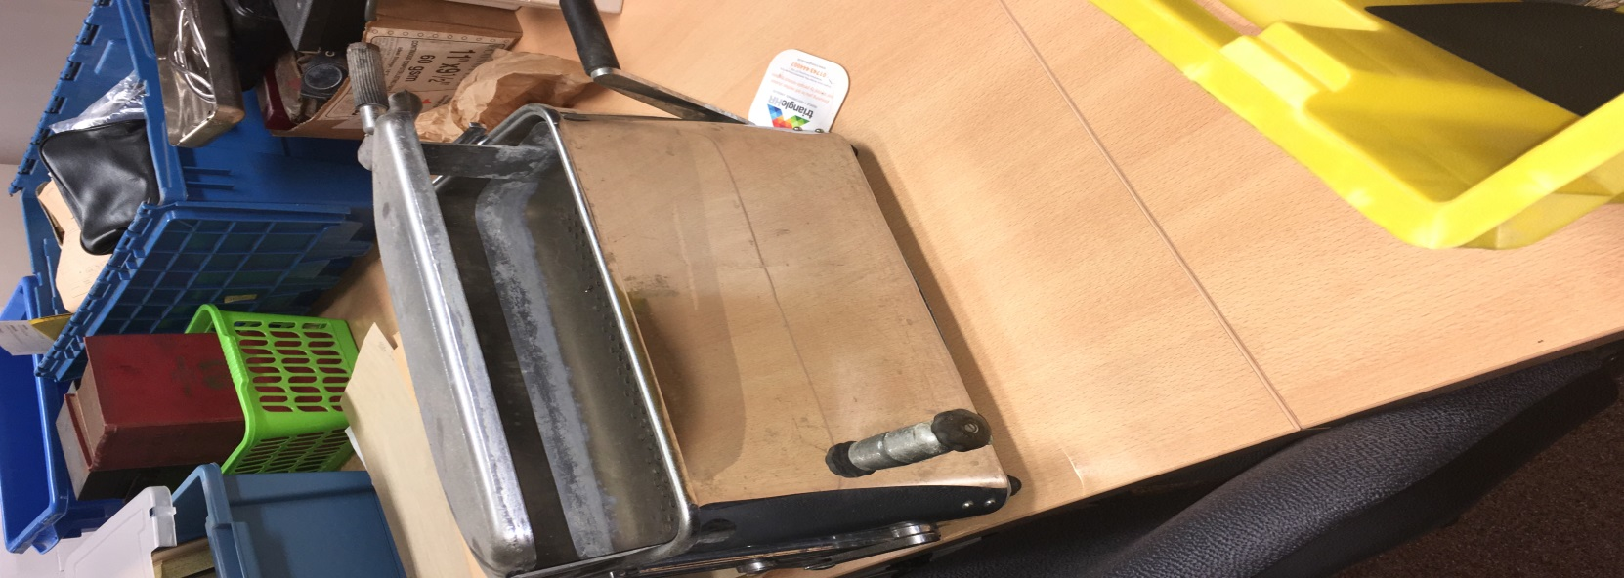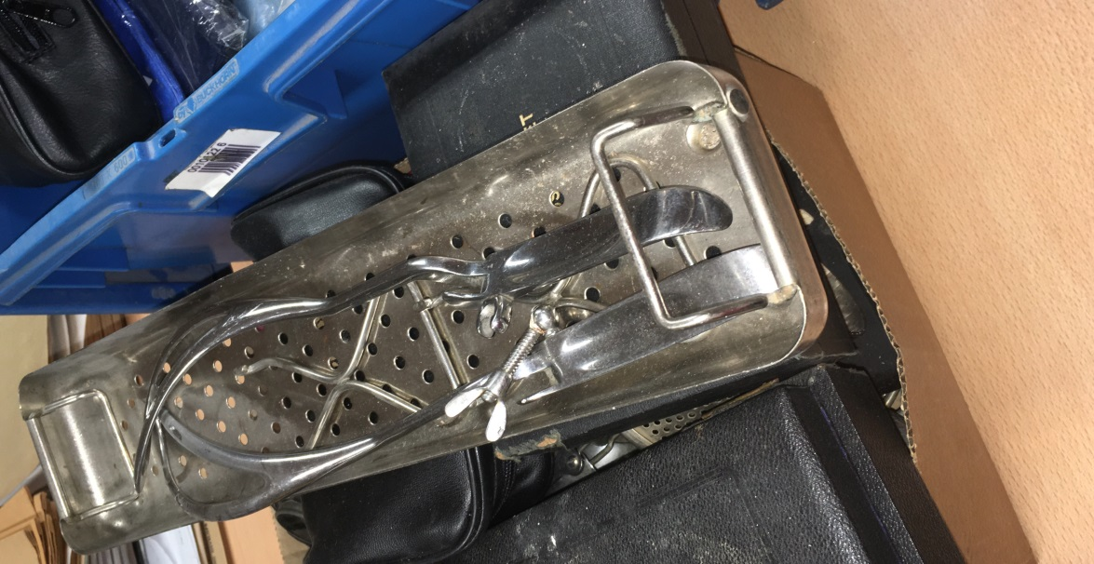

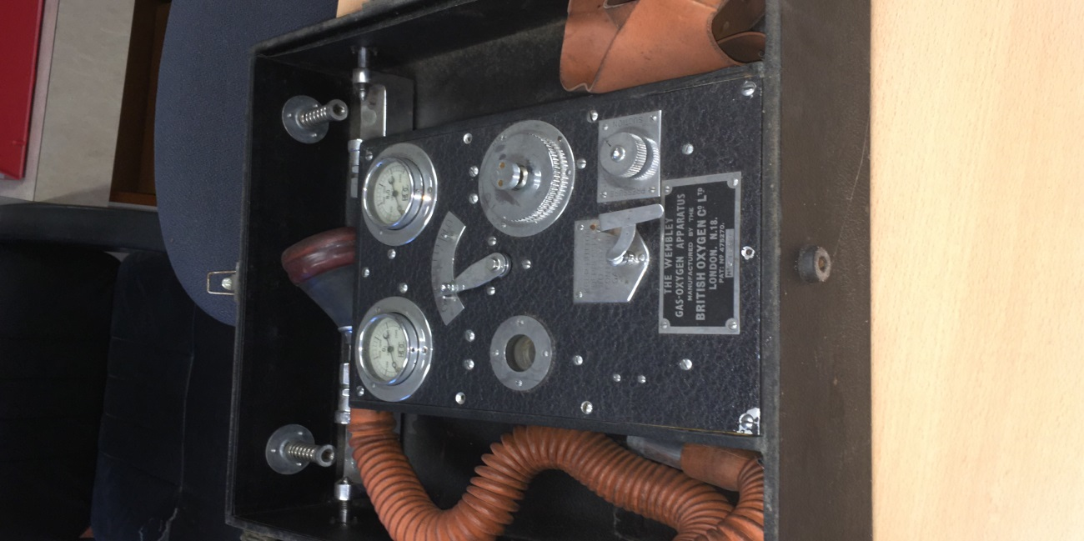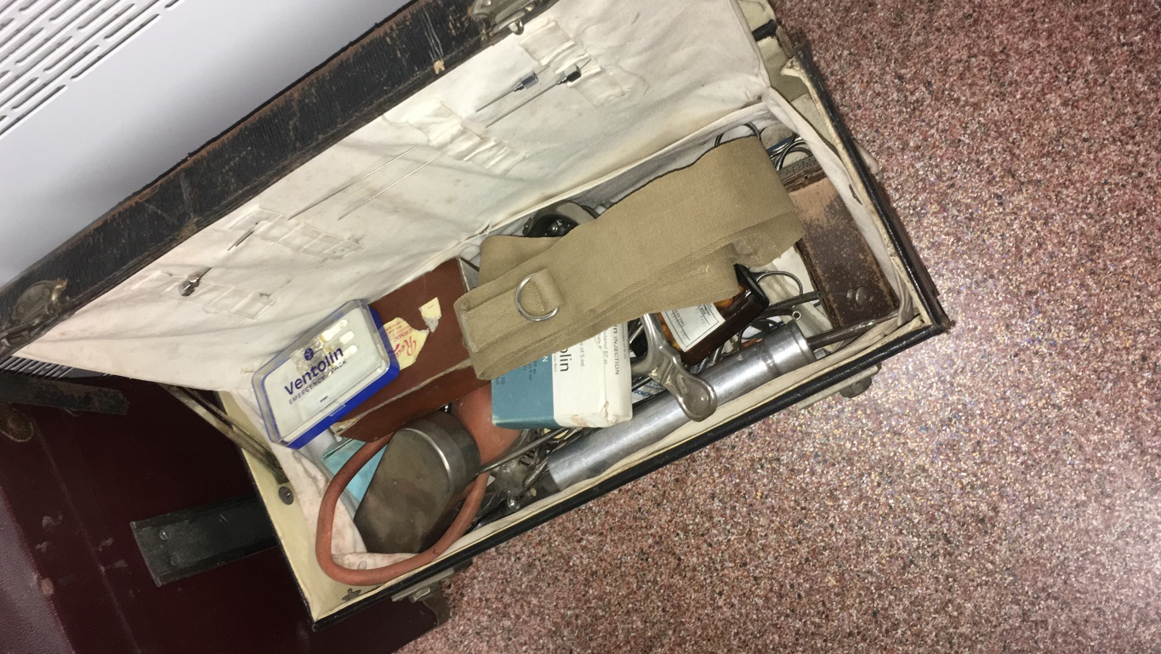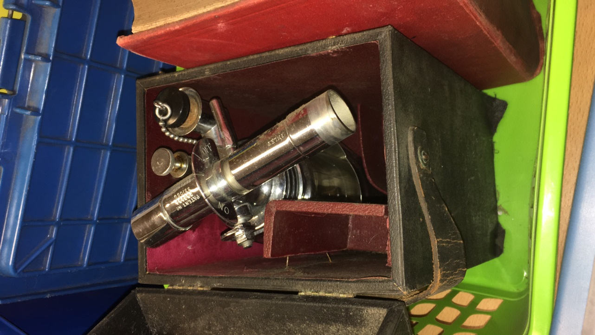

[](https://www.google.com/url?sa=i&rct=j&q=&esrc=s&source=images&cd=&ved=2ahUKEwjz7OCQ-5bnAhVhA2MBHVwQDVIQjRx6BAgBEAQ&url=https://webcomicms.net/clipart-9858355-picture-cartoon-house&psig=AOvVaw24MH81RRl7eMLfcq0IQSrg&ust=1579774054762905)

**Self-Care**

**Stock your medicine cabinet**

**Minor cuts and grazes**

**Bruises and minor sprains**

**Coughs and colds**

**Minor illnesses**

**Headache**

**Stomach upsets**

**Bites and stings**

[](https://www.google.com/url?sa=i&rct=j&q=&esrc=s&source=images&cd=&ved=2ahUKEwji9ve8_ZbnAhUT8uAKHTbkBLgQjRx6BAgBEAQ&url=https://www.lewishamccg.nhs.uk/news-publications/Pages/Pharmacy-opening-times-over-the-festive-period-2017.aspx&psig=AOvVaw3ewIRzH4-LBu0tNIuzwHcF&ust=1579774685427537)

**Pharmacy**

**Feeling unwell?**

**Anxious?**

**Need help?**

[](https://www.google.com/url?sa=i&rct=j&q=&esrc=s&source=images&cd=&ved=2ahUKEwj5-ZbS_5bnAhXaAWMBHXOPBqkQjRx6BAgBEAQ&url=https://www.iconfinder.com/icons/2329623/cartoon_communication_connection_phone_receiver_telephone_icon&psig=AOvVaw2jyg0AZMgFLn9huhNsBCCu&ust=1579775059377219)

**NHS 111**

**Persistent symptoms**

**Chronic pain**

**Long term conditions**

[](https://www.google.com/url?sa=i&rct=j&q=&esrc=s&source=images&cd=&ved=2ahUKEwj7-OaVhpfnAhXgAGMBHaZ8AqkQjRx6BAgBEAQ&url=https://www.gardenlanemedicalcentre.co.uk/info.aspx?p%3D15&psig=AOvVaw35r4u4KnFszwlZTH9zztNY&ust=1579777013602789)

**GP Advice**

**Out of Hours call 111**

[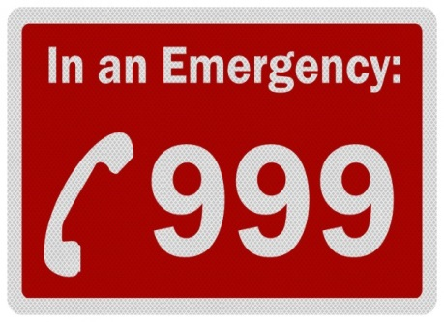](https://chimpreports.com/kenya-police-receive-a-million-emergency-calls-in-a-month/)

**Choking**

**Chest Pain**

**Blacking out**

**Serious blood loss**

**A&E or 999**

**Change in Contact Details?**

Please ensure if you change your telephone details or address you inform one of the receptionists. This helps us to keep our records as accurate as possible.

**FLU JAB!!**

If you are entitled to a flu jab and have not had it please contact the surgery to book an appointment.

**Ipsos Mori GP Survey**

**Look out for the Ipsos Mori GP Patient Survey hitting your door mat! Only a small percentage of patient’s will receive a survey, therefore every response counts. If you have received one we would really appreciate it if you could take the time to complete the questionnaire. If you are in anyway disappointed with the service please don’t hesitate to talk to us first.**

**We hope that you will have noticed the improvements we have made to our practice over the last 2 years, Dr Angela Jones joining us, more nursing hours and more support staff. For example our social prescriber and community care co-ordinator.**

**Thank you in advance from the team at Claremont Bank Surgery**